**DN 4.0 JAVA FSE SOLUTIONS – WEEK 3**

**SKILL: Spring Core and Maven**

**Exercise 1**: **Configuring a Basic Spring Application**

**Scenario**: Your company is developing a web application for managing a library. You need to use the Spring Framework to handle the backend operations.

**Code:**

**src/main/resources/applicationContext.xml**

<?xml version="1.0" encoding="UTF-8"?>

<beans xmlns="http://www.springframework.org/schema/beans"

xmlns:xsi="http://www.w3.org/2001/XMLSchema-instance"

xsi:schemaLocation="http://www.springframework.org/schema/beans

http://www.springframework.org/schema/beans/spring-beans.xsd">

<!-- Repository Bean -->

<bean id="bookRepository" class="com.library.repository.BookRepository" />

<!-- Service Bean with dependency injection -->

<bean id="bookService" class="com.library.service.BookService">

<property name="bookRepository" ref="bookRepository"/>

</bean>

</beans>

**src/main/java/com/library/repository/BookRepository.java**

package com.library.repository;

public class BookRepository {

public void saveBook(String bookName) {

System.out.println("Book saved: " + bookName);

}}

**src/main/java/com/library/service/BookService.java**

package com.library.service;

import com.library.repository.BookRepository;

public class BookService {

private BookRepository bookRepository;

public void setBookRepository(BookRepository bookRepository) {

this.bookRepository = bookRepository;

}

public void addBook(String bookName) {

bookRepository.saveBook(bookName);

}

}

**src/main/java/com/library/LibraryApp.java**

package com.library;

import com.library.service.BookService;

import org.springframework.context.ApplicationContext;

import org.springframework.context.support.ClassPathXmlApplicationContext;

public class LibraryApp {

public static void main(String[] args) {

ApplicationContext context = new ClassPathXmlApplicationContext("applicationContext.xml");

BookService bookService = (BookService) context.getBean("bookService");

bookService.addBook("Atomic Habits ");

}

}

**Output:**

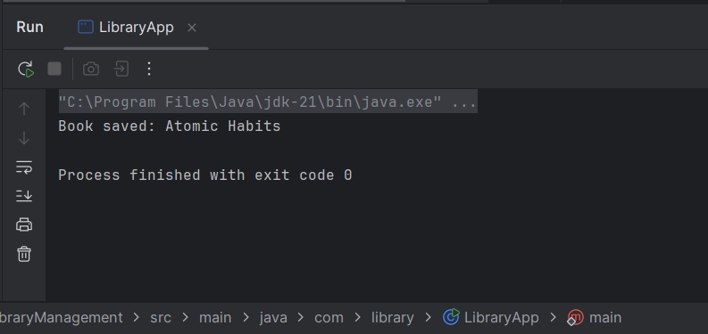

**Exercise 2: Implementing Dependency Injection**

**Scenario:** In the library management application, you need to manage the dependencies between the BookService and BookRepository classes using Spring's IoC and DI.

**Code:**

**src/main/resources/applicationContext.xml**

<?xml version="1.0" encoding="UTF-8"?>

<beans xmlns="http://www.springframework.org/schema/beans"

xmlns:xsi="http://www.w3.org/2001/XMLSchema-instance"

xsi:schemaLocation="http://www.springframework.org/schema/beans

http://www.springframework.org/schema/beans/spring-beans.xsd">

<!-- Bean for BookRepository -->

<bean id="bookRepository" class="com.library.repository.BookRepository" />

<!-- Bean for BookService with dependency injected -->

<bean id="bookService" class="com.library.service.BookService">

<property name="bookRepository" ref="bookRepository"/>

</bean>

</beans>

**src/main/java/com/library/repository/BookRepository.java**

package com.library.repository;

public class BookRepository {

public void saveBook(String bookName) {

System.out.println("Book saved: " + bookName);

}}

**src/main/java/com/library/service/BookService.java**

package com.library.service;

import com.library.repository.BookRepository;

public class BookService {

private BookRepository bookRepository;

// Setter method for Spring to inject dependency

public void setBookRepository(BookRepository bookRepository) {

this.bookRepository = bookRepository;

}

public void addBook(String bookName) {

bookRepository.saveBook(bookName);

}

}

**src/main/java/com/library/LibraryApp.java**

package com.library;

import com.library.service.BookService;

import org.springframework.context.ApplicationContext;

import org.springframework.context.support.ClassPathXmlApplicationContext;

public class LibraryApp {

public static void main(String[] args) {

// Load the Spring context from XML

ApplicationContext context = new ClassPathXmlApplicationContext("applicationContext.xml");

// Get the bookService bean

BookService bookService = (BookService) context.getBean("bookService");

// Call the method to test the injected repository

bookService.addBook("To Kill a Mockingbird");

}

}

**Output:**

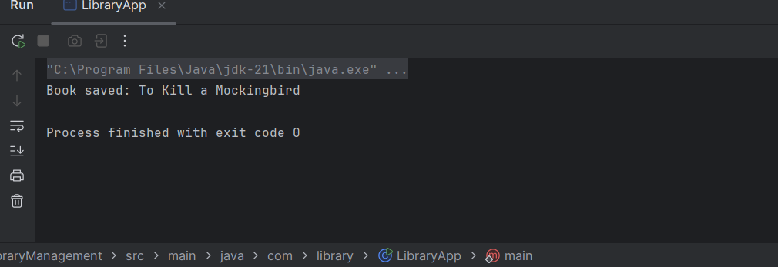

**Exercise 4: Creating and Configuring a Maven Project**

**Scenario:**

You need to set up a new Maven project for the library management application and add Spring dependencies.

**Code:**

<?xml version="1.0" encoding="UTF-8"?>  
<project xmlns="http://maven.apache.org/POM/4.0.0"  
 xmlns:xsi="http://www.w3.org/2001/XMLSchema-instance"  
 xsi:schemaLocation="http://maven.apache.org/POM/4.0.0  
 http://maven.apache.org/xsd/maven-4.0.0.xsd">  
  
 <modelVersion>4.0.0</modelVersion>  
  
 <groupId>org.example</groupId>  
 <artifactId>LibraryManagementWeb</artifactId>  
 <version>1.0-SNAPSHOT</version>  
  
 <properties>  
 <project.build.sourceEncoding>UTF-8</project.build.sourceEncoding>  
 <maven.compiler.source>1.8</maven.compiler.source>  
 <maven.compiler.target>1.8</maven.compiler.target>  
 </properties>  
  
 <dependencies>  
 <!-- Spring Context for core application context features -->  
 <dependency>  
 <groupId>org.springframework</groupId>  
 <artifactId>spring-context</artifactId>  
 <version>5.3.31</version>  
 </dependency>  
  
 <!-- Spring AOP for aspect-oriented programming -->  
 <dependency>  
 <groupId>org.springframework</groupId>  
 <artifactId>spring-aop</artifactId>  
 <version>5.3.31</version>  
 </dependency>  
  
 <!-- Spring WebMVC for building web applications -->  
 <dependency>  
 <groupId>org.springframework</groupId>  
 <artifactId>spring-webmvc</artifactId>  
 <version>5.3.31</version>  
 </dependency>  
 </dependencies>  
  
 <build>  
 <plugins>  
 <!-- Maven Compiler Plugin to specify Java version -->  
 <plugin>  
 <groupId>org.apache.maven.plugins</groupId>  
 <artifactId>maven-compiler-plugin</artifactId>  
 <version>3.10.1</version>  
 <configuration>  
 <source>1.8</source>  
 <target>1.8</target>  
 </configuration>  
 </plugin>  
 </plugins>  
 </build>  
  
</project>

**Output :**

